**Original Image:**

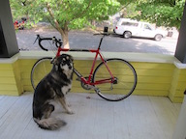

**Nearest Neighbor Interpolation Result:**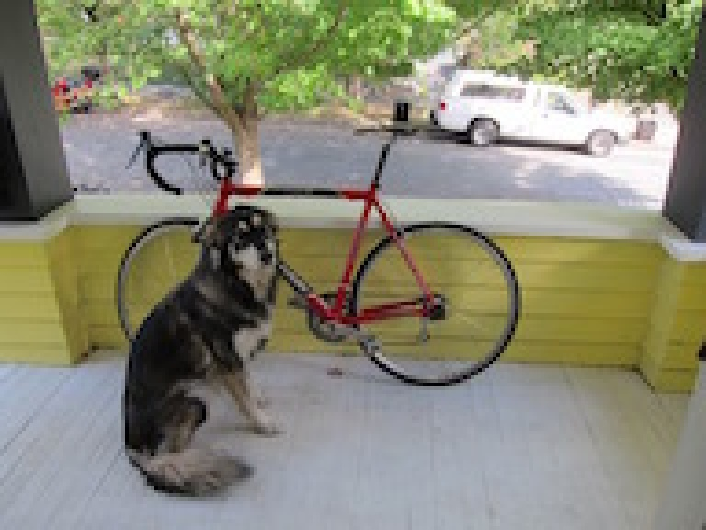

**Nearest Neighbor Code:**

def nn_resize(im, dim):

# Create new image with size dim and im number of channels

newimage = np.ones([dim[1], dim[0], im.shape[2]], dtype = "uint8")

ratiox = dim[1] / im.shape[0]

ratioy = dim[0] / im.shape[1]

offsetx = (im.shape[0] - dim[1]) / (2 * dim[1] + 1)

offsety = (im.shape[1] - dim[0]) / (2 * dim[0] + 1)

# Loop over pixels and map back to old coordinates

for x in range(0, dim[1]):

for y in range(0, dim[0]):

# Use nearest-neighbor interpolate to fill in the image

srcx = min(int(round(x / ratiox + offsetx)), im.shape[0] - 1)

srcy = min(int(round(y / ratioy + offsety)), im.shape[1] - 1)

newimage[x][y] = im[srcx][srcy]

return newimage

**Bilinear Interpolation Result:** 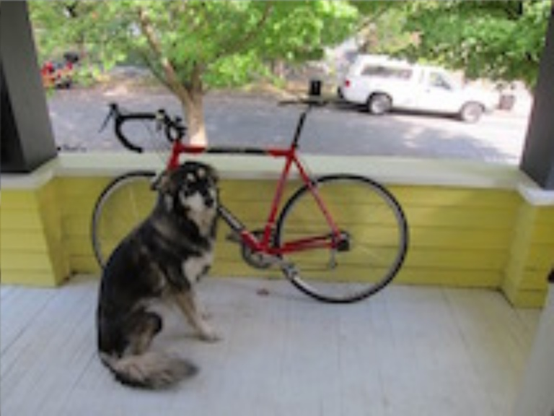

**Bilinear Code:**

def bilinear_resize(im, dim):

# Create new image with size dim and im number of channels

newimage = np.ones([dim[1], dim[0], im.shape[2]], dtype = "uint8")

ratiox = dim[1] / im.shape[0]

ratioy = dim[0] / im.shape[1]

width = im.shape[0] - 1

height = im.shape[1] - 1

offsetx = (im.shape[0] - dim[1]) / (2 * dim[1] + 1)

offsety = (im.shape[1] - dim[0]) / (2 * dim[0] + 1)

print(offsetx, offsety)

# Loop over pixels and map back to old coordinates

for x in range(0, dim[1]):

for y in range(0, dim[0]):

for c in range(0, im.shape[2]):

# Use bilinear interpolate to fill in the image

d1 = x/ratiox + offsetx - math.floor(x/ratiox + offsetx)

d2 = 1 - d1

d3 = y/ratioy + offsety - math.floor(y/ratioy + offsety)

d4 = 1 - d3

v1 = im[math.floor(x/ratiox + offsetx)][math.floor(y/ratioy + offsety)][c]

v2 = im[min(math.floor(x/ratiox + offsetx) + 1, width)][math.floor(y/ratioy + offsety)][c]

v3 = im[math.floor(x/ratiox + offsetx)][min(math.floor(y/ratioy + offsety) + 1, height)][c]

v4 = im[min(math.floor(x/ratiox + offsetx) + 1, width)][min(math.floor(y/ratioy + offsety) + 1, height)][c]

a4 = d1 * d3 / ((d1 + d2) * (d3 + d4))

a3 = d2 * d3 / ((d1 + d2) * (d3 + d4))

a2 = d1 * d4 / ((d1 + d2) * (d3 + d4))

a1 = d2 * d4 / ((d1 + d2) * (d3 + d4))

q = v1 * a1 + v2 * a2 + v3 * a3 + v4 * a4

newimage[x][y][c] = q

return newimage